1. **Introduction** 
   1. **Overview:-**

In 2017 in the United States, which represented about a third of the global video game market, the Entertainment Software Association estimated that there were over 2,300 development companies and over 525 publishing companies, including in hardware and software manufacturing, service providers, and distributors. These companies in total have nearly 66,000 direct employees. When including indirect employment, such as a developer using the services of a graphics design package from a different firm, the total number of employees involved in the video game industry rises above 220,000.[6]. The video game industry encompasses the development, marketing, and monetization of video games. The industry encompasses dozens of job disciplines and thousands of jobs worldwide.

* 1. **Purpose**

Educational games are multi-sensorial environments where mastery and skill are rewarded. Affective gaming focuses on influencing and identifying the player's emotional state. An Intelligent Tutoring System (ITS) is incorporated into a game-based learning environment to achieve effective assessment criteria. Research has shown that games are essential for healthy development in early childhood and beyond. Play lets children practise what they know, and also what they don't. It allows them to experiment through trial and error, find solutions to problems, work out the best strategies, and build new confidence and skills.

1. **Problem definition & design thinking.**

**2.1 Empathy Map**

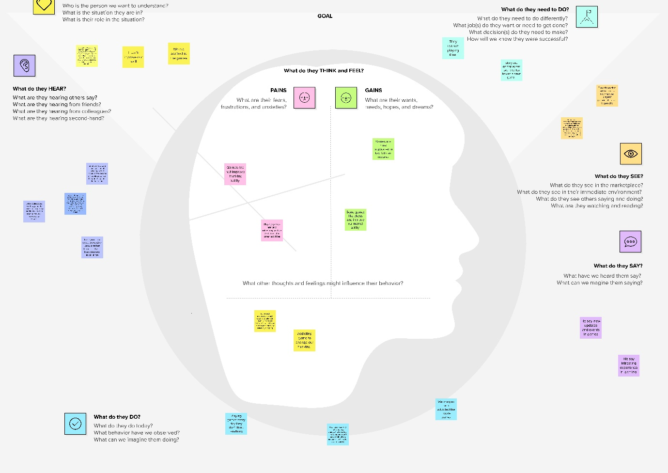

**2.2 Brainstorming Map:-**

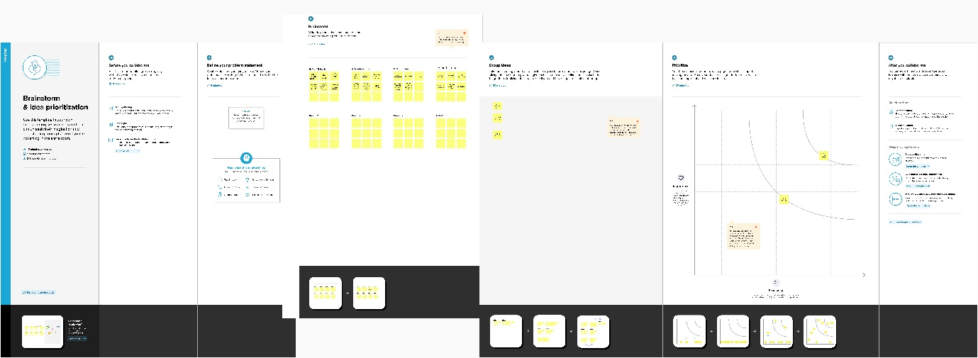

1

**3 Result:-**

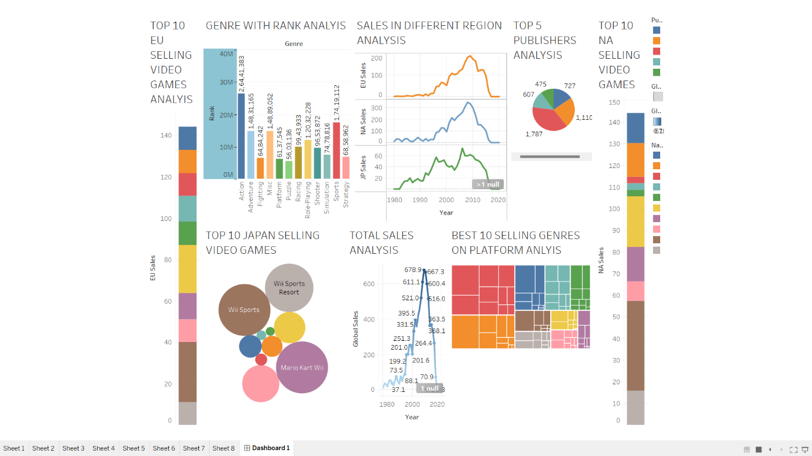

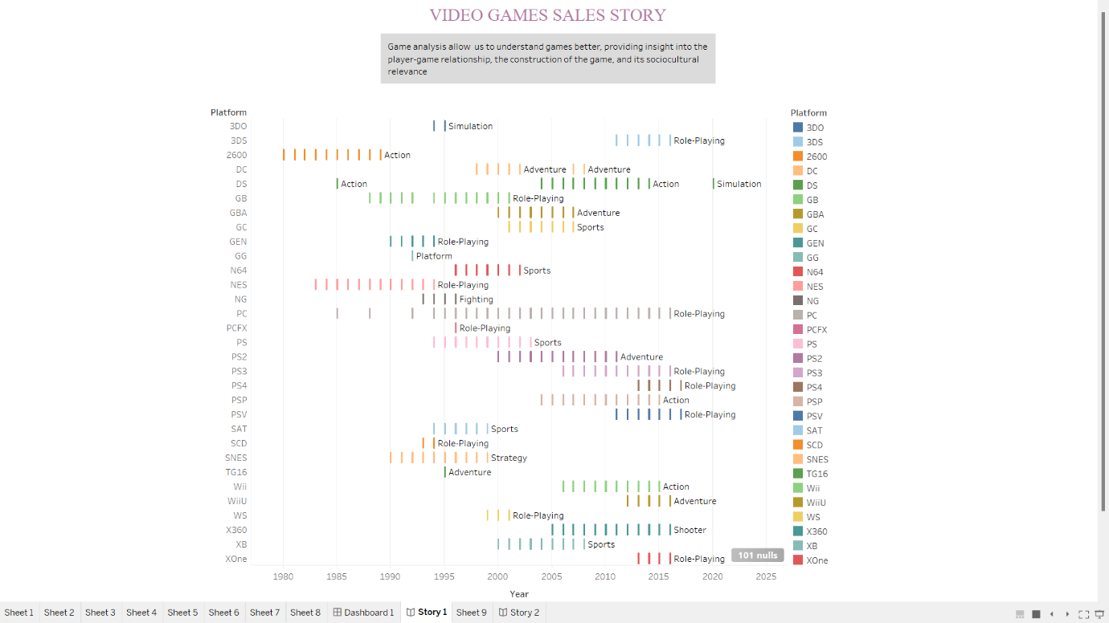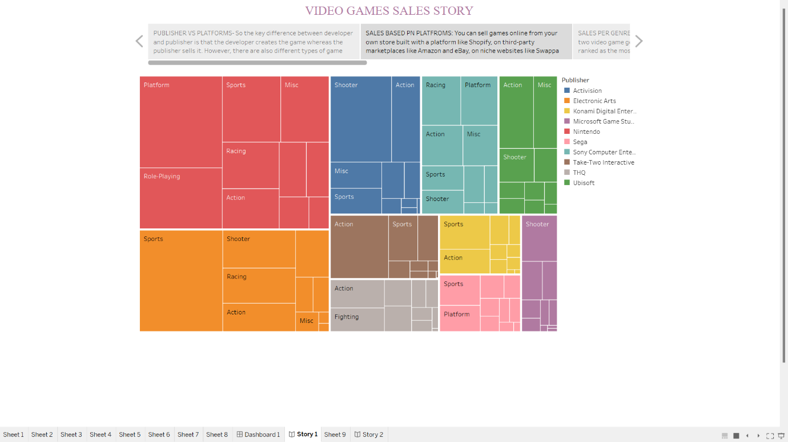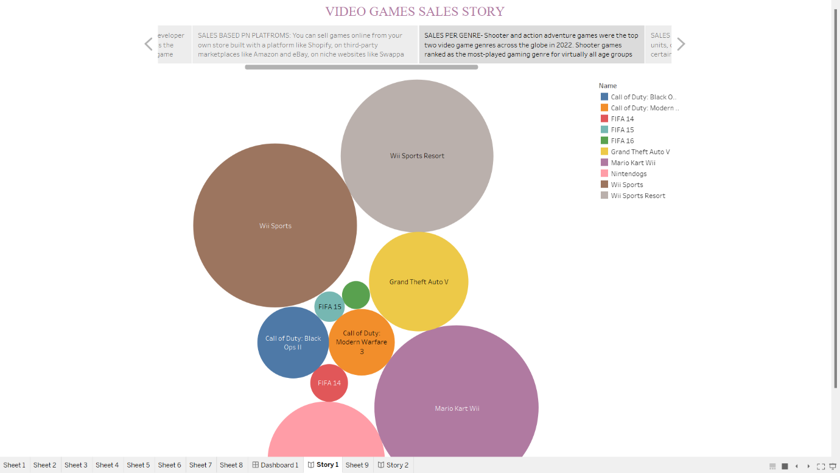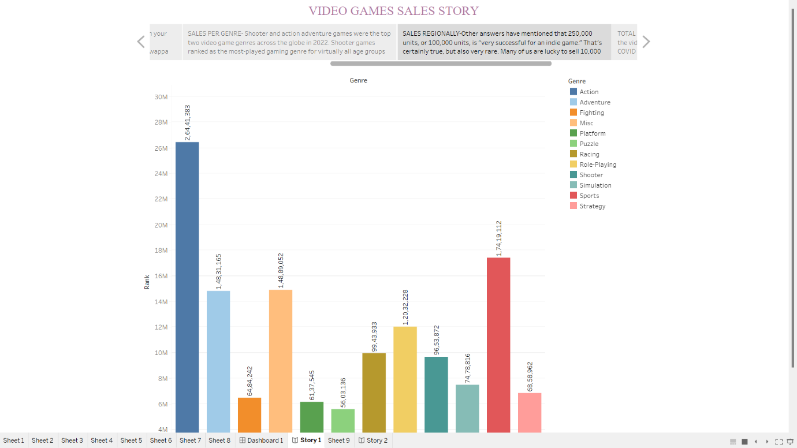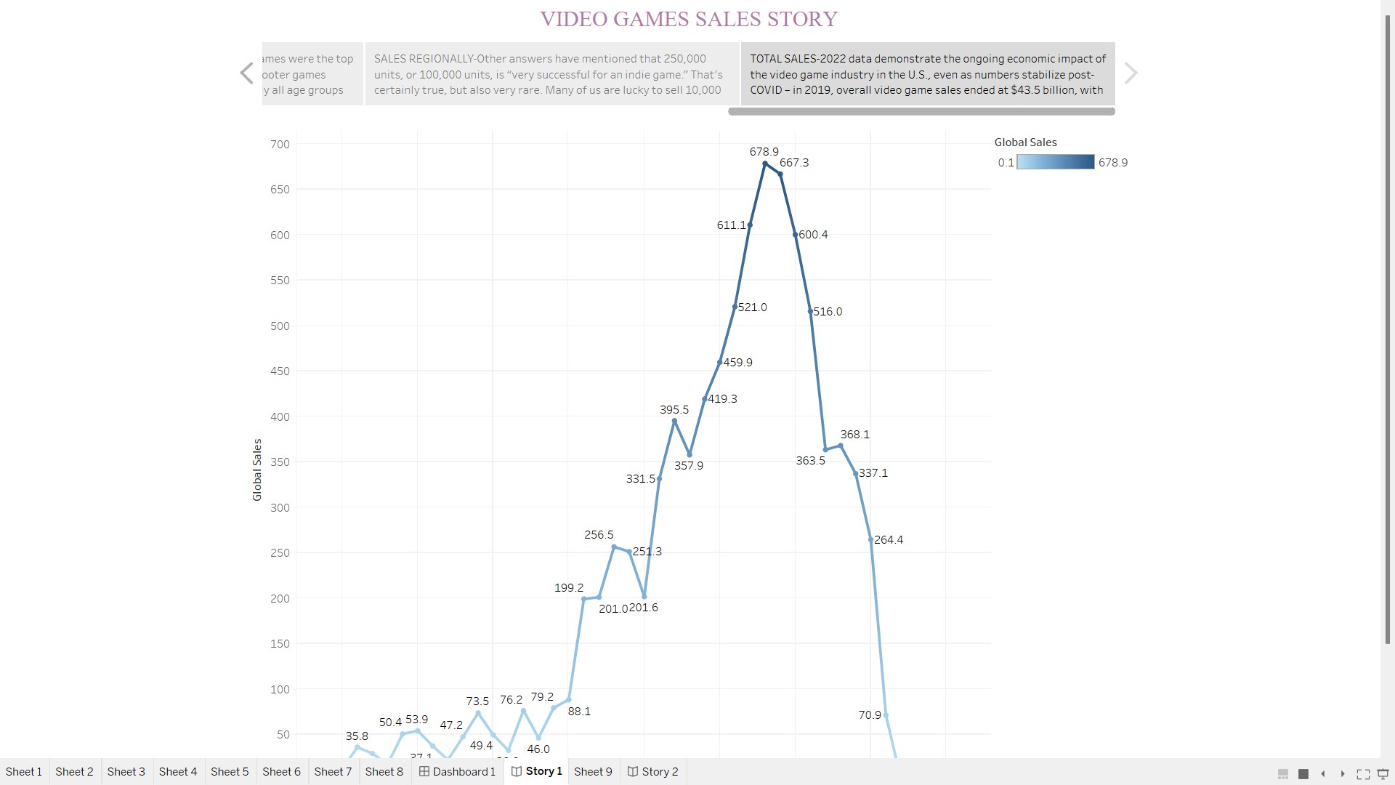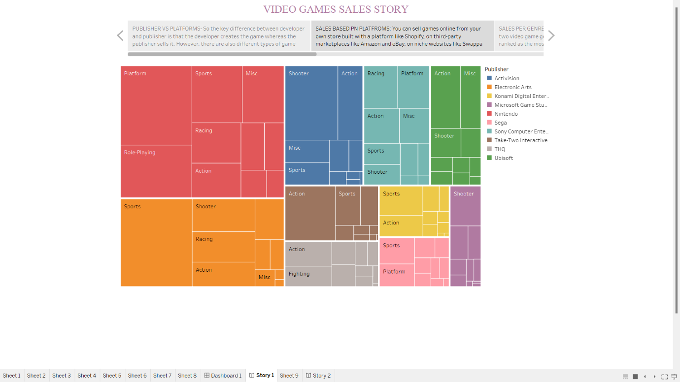

**4 Advantages& Disadvantage:-**

**Advantages:-**

* They speed up response times.
* They encourage teamwork.
* They stimulate creativity, focus and visual memory.
* They improve strategy and leadership.
* They teach languages.
* Critical thinking.

**Disadvantages:-**

* Addition. Video games are addictive if you keep playing them without any break.
* Some Games Contains Violence.
* Health Problem.
* Might Limit Academic Progress.
* Might Get Victim of Cyberbullying and Scamming

**5 Application:-**

A gaming application is a web, mobile, or desktop application that enables users to play games against each other. Gaming apps may also include features for managing the game and interacting with friends. Games are often categorized as either casual games or immersive, engaging games.

**6 Conclusion:-**

Video games are a form of media that is often associated with negative health consequences. However, when games are played in moderation and with mindfulness, they are a viable source of stress relief as well as a catalyst for mental health improvement and development of social skills**.**

**7 Future scope:-**

Game Designing is one of the most upcoming Courses for students who wanted to make a Game Designer Career in India in animation. The gaming industry is rapidly growing at a pace of 50% per annum. There is a very wide and bright future in game design in India. Students can earn up to 3 Lakh to 5 Lakh PA.

**8.Appendix**

<!DOCTYPE html>

<html lang="en">

<head>

  <meta charset="utf-8">

  <meta content="width=device-width, initial-scale=1.0" name="viewport">

  <title>Video Games Sales Analysis</title>

  <meta content="" name="description">

  <meta content="" name="keywords">

  <!-- Favicons -->

  <link href="assets/img/favicon.png" rel="icon">

  <link href="assets/img/apple-touch-icon.png" rel="apple-touch-icon">

  <!-- Google Fonts -->

  <link href="https://fonts.googleapis.com/css?family=Open+Sans:300,300i,400,400i,600,600i,700,700i|Raleway:300,300i,400,400i,500,500i,600,600i,700,700i|Poppins:300,300i,400,400i,500,500i,600,600i,700,700i" rel="stylesheet">

  <!-- Vendor CSS Files -->

  <link href="assets/vendor/aos/aos.css" rel="stylesheet">

  <link href="assets/vendor/bootstrap/css/bootstrap.min.css" rel="stylesheet">

  <link href="assets/vendor/bootstrap-icons/bootstrap-icons.css" rel="stylesheet">

  <link href="assets/vendor/boxicons/css/boxicons.min.css" rel="stylesheet">

  <link href="assets/vendor/glightbox/css/glightbox.min.css" rel="stylesheet">

  <link href="assets/vendor/remixicon/remixicon.css" rel="stylesheet">

  <link href="assets/vendor/swiper/swiper-bundle.min.css" rel="stylesheet">

  <!-- Template Main CSS File -->

  <link href="assets/css/style.css" rel="stylesheet">

  <!-- =======================================================

  * Template Name: Presento - v3.9.1

  * Template URL: https://bootstrapmade.com/presento-bootstrap-corporate-template/

  * Author: BootstrapMade.com

  * License: https://bootstrapmade.com/license/

  ======================================================== -->

</head>

<body>

  <!-- ======= Header ======= -->

  <header id="header" class="fixed-top d-flex align-items-center">

    <div class="container d-flex align-items-center">

      <h3 class="logo me-auto"><a href="index.html">VIDEO GAMES SALES ANALYSIS<span>.</span></a></h3>

      <!-- Uncomment below if you prefer to use an image logo -->

      <!-- <a href="index.html" class="logo me-auto"><img src="assets/img/logo.png" alt=""></a>-->

      <nav id="navbar" class="navbar order-last order-lg-0">

        <ul>

          <li><a class="nav-link scrollto active" href="#hero">Home</a></li>

          <li><a class="nav-link scrollto" href="#about">about</a></li>

          <li><a class="nav-link scrollto" href="#services">overview</a></li>

          <li><a class="nav-link scrollto" href="#team">Dashboard</a></li>

          <li><a class="nav-link scrollto" href="#Story">Story</a></li>

          <li><a class="nav-link scrollto" href="#Report">review</a></li>

        <!--  <li class="dropdown"><a href="#"><span>Drop Down</span> <i class="bi bi-chevron-down"></i></a>

            <ul>

              <li><a href="#">Drop Down 1</a></li>

              <li class="dropdown"><a href="#"><span>Deep Drop Down</span> <i class="bi bi-chevron-right"></i></a>

                <ul>

                  <li><a href="#">Deep Drop Down 1</a></li>

                  <li><a href="#">Deep Drop Down 2</a></li>

                  <li><a href="#">Deep Drop Down 3</a></li>

                  <li><a href="#">Deep Drop Down 4</a></li>

                  <li><a href="#">Deep Drop Down 5</a></li>

                </ul>

              </li>

              <li><a href="#">Drop Down 2</a></li>

              <li><a href="#">Drop Down 3</a></li>

              <li><a href="#">Drop Down 4</a></li>

            </ul>

          </li>

          <li><a class="nav-link scrollto" href="#contact">Contact</a></li>

        </ul>

        <i class="bi bi-list mobile-nav-toggle"></i>

      </nav> .navbar -->

    </div>

  </header><!-- End Header -->

  <!-- ======= Hero Section ======= -->

  <section id="hero" class="d-flex align-items-center">

    <div class="container" data-aos="zoom-out" data-aos-delay="100">

      <div class="row">

        <div class="col-xl-6">

          <h1>A Tableau Presentation</h1>

                   <a href="#about" class="btn-get-started scrollto">Get Started</a>

        </div>

      </div>

    </div>

  </section><!-- End Hero -->

  <main id="main">

    <!-- ======= Clients Section =======

    <section id="clients" class="clients">

      <div class="container" data-aos="zoom-in">

        <div class="clients-slider swiper">

          <div class="swiper-wrapper align-items-center">

            <div class="swiper-slide"><img src="assets/img/clients/client-1.png" class="img-fluid" alt=""></div>

            <div class="swiper-slide"><img src="assets/img/clients/client-2.png" class="img-fluid" alt=""></div>

            <div class="swiper-slide"><img src="assets/img/clients/client-3.png" class="img-fluid" alt=""></div>

            <div class="swiper-slide"><img src="assets/img/clients/client-4.png" class="img-fluid" alt=""></div>

            <div class="swiper-slide"><img src="assets/img/clients/client-5.png" class="img-fluid" alt=""></div>

            <div class="swiper-slide"><img src="assets/img/clients/client-6.png" class="img-fluid" alt=""></div>

            <div class="swiper-slide"><img src="assets/img/clients/client-7.png" class="img-fluid" alt=""></div>

            <div class="swiper-slide"><img src="assets/img/clients/client-8.png" class="img-fluid" alt=""></div>

          </div>

          <div class="swiper-pagination"></div>

        </div>

      </div>

    </section><!-- End Clients Section -->

    <!-- ======= About Section ======= -->

    <section id="about" class="about section-bg">

      <div class="container" data-aos="fade-up">

        <div class="row no-gutters">

          <div class="content col-xl-5 d-flex align-items-stretch">

            <div class="content">

              <p>

                Video Games since it's inception has touched many souls by their augmented reality and graphics,apart from being a good to boredom it also shows us the way technology has been developed from single Ninendo to PS5, from road rash to God of war.

              </p>

              <p>This project is a complete analysis of video games sold since 1980.It consist of video games with their publisher and platform with the genre of games on which year they were published with the sales they made in North America,Japan,Europe and other regions.

              </p>

            </div>

          </div>

          <div class="col-xl-7 d-flex align-items-stretch">

            <div class="icon-boxes d-flex flex-column justify-content-center">

              <div class="row">

                <div class="col-md-6 icon-box" data-aos="fade-up" data-aos-delay="100">

                <!--  <i class="bx bx-receipt"></i>

                  <h4>Super Mario Bros</h4>

                  <p>Super Mario Bros is a platform game developed and published by Nintendo for the Nintendo Entertainment System(NES).</p>

                </div>

                <div class="col-md-6 icon-box" data-aos="fade-up" data-aos-delay="200">

                  <i class="bx bx-cube-alt"></i>

                  <h4>Wii Sports</h4>

                  <p>Wii Sports is a 2006 sports simulation video game developed and published by Nintendo for the Wii video game console.</p>

                </div>

                <div class="col-md-6 icon-box" data-aos="fade-up" data-aos-delay="300">

                  <i class="bx bx-images"></i>

                  <h4>Labore consequatur</h4>

                  <p>ut suscipit aut cum nemo deleniti aut omnis. Doloribus ut maiores omnis facere</p>

                </div>

                <div class="col-md-6 icon-box" data-aos="fade-up" data-aos-delay="400">

                  <i class="bx bx-shield"></i>

                  <h4>Beatae veritatis</h4>

                  <p>Expedita veritatis consequuntur nihil tempore laudantium vitae denat pacta</p>

                </div>

              </div>

            </div>End .content

          </div>End .content

        </div>

      </div>End .content-->

    </section><!-- End About Section -->

    <!-- ======= Counts Section ======= -->

    <!--<section id="counts" class="counts">

      <div class="container" data-aos="fade-up">

        <div class="row">

          <div class="col-lg-3 col-md-6">

            <div class="count-box">

              <i class="bi bi-emoji-smile"></i>

              <span data-purecounter-start="0" data-purecounter-end="232" data-purecounter-duration="1" class="purecounter"></span>

              <p>Happy Clients</p>

            </div>

          </div>

          <div class="col-lg-3 col-md-6 mt-5 mt-md-0">

            <div class="count-box">

              <i class="bi bi-journal-richtext"></i>

              <span data-purecounter-start="0" data-purecounter-end="521" data-purecounter-duration="1" class="purecounter"></span>

              <p>Projects</p>

            </div>

          </div>

          <div class="col-lg-3 col-md-6 mt-5 mt-lg-0">

            <div class="count-box">

              <i class="bi bi-headset"></i>

              <span data-purecounter-start="0" data-purecounter-end="1463" data-purecounter-duration="1" class="purecounter"></span>

              <p>Hours Of Support</p>

            </div>

          </div>

          <div class="col-lg-3 col-md-6 mt-5 mt-lg-0">

            <div class="count-box">

              <i class="bi bi-people"></i>

              <span data-purecounter-start="0" data-purecounter-end="15" data-purecounter-duration="1" class="purecounter"></span>

              <p>Hard Workers</p>

            </div>

          </div>

        </div>

      </div>

    </section> End Counts Section -->

    <!-- ======= Tabs Section ======= -->

    <!--<section id="tabs" class="tabs">

      <div class="container" data-aos="fade-up">

        <ul class="nav nav-tabs row d-flex">

          <li class="nav-item col-3">

            <a class="nav-link active show" data-bs-toggle="tab" data-bs-target="#tab-1">

              <i class="ri-gps-line"></i>

              <h4 class="d-none d-lg-block">Modi sit est dela pireda nest</h4>

            </a>

          </li>

          <li class="nav-item col-3">

            <a class="nav-link" data-bs-toggle="tab" data-bs-target="#tab-2">

              <i class="ri-body-scan-line"></i>

              <h4 class="d-none d-lg-block">Unde praesenti mara setra le</h4>

            </a>

          </li>

          <li class="nav-item col-3">

            <a class="nav-link" data-bs-toggle="tab" data-bs-target="#tab-3">

              <i class="ri-sun-line"></i>

              <h4 class="d-none d-lg-block">Pariatur explica nitro dela</h4>

            </a>

          </li>

          <li class="nav-item col-3">

            <a class="nav-link" data-bs-toggle="tab" data-bs-target="#tab-4">

              <i class="ri-store-line"></i>

              <h4 class="d-none d-lg-block">Nostrum qui dile node</h4>

            </a>

          </li>

        </ul>

        <div class="tab-content">

          <div class="tab-pane active show" id="tab-1">

            <div class="row">

              <div class="col-lg-6 order-2 order-lg-1 mt-3 mt-lg-0" data-aos="fade-up" data-aos-delay="100">

                <h3>Voluptatem dignissimos provident quasi corporis voluptates sit assumenda.</h3>

                <p class="fst-italic">

                  Lorem ipsum dolor sit amet, consectetur adipiscing elit, sed do eiusmod tempor incididunt ut labore et dolore

                  magna aliqua.

                </p>

                <ul>

                  <li><i class="ri-check-double-line"></i> Ullamco laboris nisi ut aliquip ex ea commodo consequat.</li>

                  <li><i class="ri-check-double-line"></i> Duis aute irure dolor in reprehenderit in voluptate velit.</li>

                  <li><i class="ri-check-double-line"></i> Ullamco laboris nisi ut aliquip ex ea commodo consequat. Duis aute irure dolor in reprehenderit in voluptate trideta storacalaperda mastiro dolore eu fugiat nulla pariatur.</li>

                </ul>

                <p>

                  Ullamco laboris nisi ut aliquip ex ea commodo consequat. Duis aute irure dolor in reprehenderit in voluptate

                  velit esse cillum dolore eu fugiat nulla pariatur. Excepteur sint occaecat cupidatat non proident, sunt in

                  culpa qui officia deserunt mollit anim id est laborum

                </p>

              </div>

              <div class="col-lg-6 order-1 order-lg-2 text-center" data-aos="fade-up" data-aos-delay="200">

                <img src="assets/img/tabs-1.jpg" alt="" class="img-fluid">

              </div>

            </div>

          </div>

          <div class="tab-pane" id="tab-2">

            <div class="row">

              <div class="col-lg-6 order-2 order-lg-1 mt-3 mt-lg-0">

                <h3>Neque exercitationem debitis soluta quos debitis quo mollitia officia est</h3>

                <p>

                  Ullamco laboris nisi ut aliquip ex ea commodo consequat. Duis aute irure dolor in reprehenderit in voluptate

                  velit esse cillum dolore eu fugiat nulla pariatur. Excepteur sint occaecat cupidatat non proident, sunt in

                  culpa qui officia deserunt mollit anim id est laborum

                </p>

                <p class="fst-italic">

                  Lorem ipsum dolor sit amet, consectetur adipiscing elit, sed do eiusmod tempor incididunt ut labore et dolore

                  magna aliqua.

                </p>

                <ul>

                  <li><i class="ri-check-double-line"></i> Ullamco laboris nisi ut aliquip ex ea commodo consequat.</li>

                  <li><i class="ri-check-double-line"></i> Duis aute irure dolor in reprehenderit in voluptate velit.</li>

                  <li><i class="ri-check-double-line"></i> Provident mollitia neque rerum asperiores dolores quos qui a. Ipsum neque dolor voluptate nisi sed.</li>

                  <li><i class="ri-check-double-line"></i> Ullamco laboris nisi ut aliquip ex ea commodo consequat. Duis aute irure dolor in reprehenderit in voluptate trideta storacalaperda mastiro dolore eu fugiat nulla pariatur.</li>

                </ul>

              </div>

              <div class="col-lg-6 order-1 order-lg-2 text-center">

                <img src="" alt="" class="img-fluid">

              </div>

            </div>

          </div>

          <div class="tab-pane" id="tab-3">

            <div class="row">

              <div class="col-lg-6 order-2 order-lg-1 mt-3 mt-lg-0">

                <h3>Voluptatibus commodi ut accusamus ea repudiandae ut autem dolor ut assumenda</h3>

                <p>

                  Ullamco laboris nisi ut aliquip ex ea commodo consequat. Duis aute irure dolor in reprehenderit in voluptate

                  velit esse cillum dolore eu fugiat nulla pariatur. Excepteur sint occaecat cupidatat non proident, sunt in

                  culpa qui officia deserunt mollit anim id est laborum

                </p>

                <ul>

                  <li><i class="ri-check-double-line"></i> Ullamco laboris nisi ut aliquip ex ea commodo consequat.</li>

                  <li><i class="ri-check-double-line"></i> Duis aute irure dolor in reprehenderit in voluptate velit.</li>

                  <li><i class="ri-check-double-line"></i> Provident mollitia neque rerum asperiores dolores quos qui a. Ipsum neque dolor voluptate nisi sed.</li>

                </ul>

                <p class="fst-italic">

                  Lorem ipsum dolor sit amet, consectetur adipiscing elit, sed do eiusmod tempor incididunt ut labore et dolore

                  magna aliqua.

                </p>

              </div>

              <div class="col-lg-6 order-1 order-lg-2 text-center">

                <img src="assets/img/tabs-3.jpg" alt="" class="img-fluid">

              </div>

            </div>

          </div>

          <div class="tab-pane" id="tab-4">

            <div class="row">

              <div class="col-lg-6 order-2 order-lg-1 mt-3 mt-lg-0">

                <h3>Omnis fugiat ea explicabo sunt dolorum asperiores sequi inventore rerum</h3>

                <p>

                  Ullamco laboris nisi ut aliquip ex ea commodo consequat. Duis aute irure dolor in reprehenderit in voluptate

                  velit esse cillum dolore eu fugiat nulla pariatur. Excepteur sint occaecat cupidatat non proident, sunt in

                  culpa qui officia deserunt mollit anim id est laborum

                </p>

                <p class="fst-italic">

                  Lorem ipsum dolor sit amet, consectetur adipiscing elit, sed do eiusmod tempor incididunt ut labore et dolore

                  magna aliqua.

                </p>

                <ul>

                  <li><i class="ri-check-double-line"></i> Ullamco laboris nisi ut aliquip ex ea commodo consequat.</li>

                  <li><i class="ri-check-double-line"></i> Duis aute irure dolor in reprehenderit in voluptate velit.</li>

                  <li><i class="ri-check-double-line"></i> Ullamco laboris nisi ut aliquip ex ea commodo consequat. Duis aute irure dolor in reprehenderit in voluptate trideta storacalaperda mastiro dolore eu fugiat nulla pariatur.</li>

                </ul>

              </div>

              <div class="col-lg-6 order-1 order-lg-2 text-center">

                <img src="assets/img/tabs-4.jpg" alt="" class="img-fluid">

              </div>

            </div>

          </div>

        </div>

      </div>

    </section>End Tabs Section -->

    <!-- ======= Services Section ======= -->

    <section id="services" class="services section-bg ">

      <div class="container" data-aos="fade-up">

        <div class="section-title">

          <h2>overview</h2>

          <p>Analysing sales data from more than 16,500 games.This dataset contains a list of video games with sales greater than 100,000 copies. It was generated by a scrape of vgchartz.com.</p>

          <p>Let us check some top sale video games</p>

        </div>

        <div class="row">

          <div class="col-md-6">

            <div class="icon-box" data-aos="fade-up" data-aos-delay="100">

              <!-- <i class="bi bi-briefcase"></i> -->

              <h4><a href="#">Super Mario Bros</a></h4>

              <p>Super Mario Bros is a platform game developed and published by Nintendo for the Nintendo Entertainment System(NES).</p>

            </div>

          </div>

          <div class="col-md-6 mt-4 mt-md-0">

            <div class="icon-box" data-aos="fade-up" data-aos-delay="200">

              <!-- <i class="bi bi-card-checklist"></i> -->

              <h4><a href="#">Wii Sports</a></h4>

              <p>Wii Sports is a 2006 sports simulation video game developed and published by Nintendo for the Wii video game console.</p>

            </div>

          </div>

          <div class="col-md-6 mt-4 mt-md-0">

            <div class="icon-box" data-aos="fade-up" data-aos-delay="300">

              <!-- <i class="bi bi-bar-chart"></i> -->

              <h4><a href="#">Pokemon Red/Pokemon Blue</a></h4>

              <p>Pokémon Red Version and Pokémon Blue Version are 1996 role-playing video games developed by Game Freak and published by Nintendo for the Game Boy.</p>

            </div>

          </div>

          <div class="col-md-6 mt-4 mt-md-0">

            <div class="icon-box" data-aos="fade-up" data-aos-delay="400">

              <!-- <i class="bi bi-binoculars"></i> -->

              <h4><a href="#">Grand Theft Auto IV</a></h4>

              <p>Grand Theft Auto IV is a 2008 action-adventure game developed by Rockstar North and published by Rockstar Games. It is the sixth main entry in the Grand Theft Auto series, following 2004's Grand Theft Auto: San Andreas.</p>

            </div>

          </div>

          <div class="col-md-6 mt-4 mt-md-0">

            <div class="icon-box" data-aos="fade-up" data-aos-delay="500">

              <!-- <i class="bi bi-brightness-high"></i> -->

              <h4><a href="#">Mine craft</a></h4>

              <p>Minecraft is a sandbox game developed by Mojang Studios. The game was created by Markus "Notch" Persson in the Java programming language.It is the best-selling video game of all time, with over 238 million copies sold and nearly 140 million monthly active players as of 2021, and has been ported to several platforms.</p>

            </div>

          </div>

          <div class="col-md-6 mt-4 mt-md-0">

            <div class="icon-box" data-aos="fade-up" data-aos-delay="600">

              <!-- <i class="bi bi-calendar4-week"></i> -->

              <h4><a href="#">FIFA 16</a></h4>

              <p>FIFA 16 is a football simulation video game developed by EA Canada and published by Electronic Arts under the EA Sports label.</p>

            </div>

          </div>

        </div>

      </div>

    </section><!-- End Services Section -->

    <!-- ======= Portfolio Section ======= -->

    <section id="portfolio" class="portfolio">

      <div class="container" data-aos="fade-up">

        <div class="section-title">

          <h2>Analysis Charts</h2>

          <p>This data consists of 16599 records with 11 columns.The visualization is done using Tableau and contains 9 analysis charts.</p>

        </div>

        <div class="row" data-aos="fade-up" data-aos-delay="100">

          <div class="col-lg-12 d-flex justify-content-center">

            <ul id="portfolio-flters">

              <li data-filter="*" class="filter-active">All</li>

              <li data-filter=".filter-app">Sales</li>

              <li data-filter=".filter-card">Genre</li>

              <li data-filter=".filter-web">Publishers</li>

            </ul>

          </div>

        </div>

        <div class="row portfolio-container" data-aos="fade-up" data-aos-delay="200">

          <div class="col-lg-4 col-md-6 portfolio-item filter-app">

            <div class="portfolio-wrap">

              <img src="Y:\image for vsd\Sheet 3.jpg" class="img-fluid" alt="">

              <div class="portfolio-info">

                <h4>Total sales</h4>

                <div class="portfolio-links">

                  <a href="Y:\image for vsd\Sheet 3.jpg" data-gallery="portfolioGallery" class="portfolio-lightbox" title="App 1"><i class="bx bx-plus"></i></a>

                </div>

              </div>

            </div>

          </div>

          <div class="col-lg-4 col-md-6 portfolio-item filter-web">

            <div class="portfolio-wrap">

              <img src="Y:\image for vsd\Sheet 4.jpg" class="img-fluid" alt="">

              <div class="portfolio-info">

                <h4>Top 5 publishers</h4>

                <div class="portfolio-links">

                  <a href="Y:\image for vsd\Sheet 4.jpg" data-gallery="portfolioGallery" class="portfolio-lightbox" title="Web 3"><i class="bx bx-plus"></i></a>

                </div>

              </div>

            </div>

          </div>

          <div class="col-lg-4 col-md-6 portfolio-item filter-app">

            <div class="portfolio-wrap">

              <img src="Y:\image for vsd\Sheet 1.jpg" class="img-fluid" alt="">

              <div class="portfolio-info">

                <h4>Sales in different region</h4>

                <div class="portfolio-links">

                  <a href="Y:\image for vsd\Sheet 1.jpg" data-gallery="portfolioGallery" class="portfolio-lightbox" title="App 2"><i class="bx bx-plus"></i></a>

                </div>

              </div>

            </div>

          </div>

          <div class="col-lg-4 col-md-6 portfolio-item filter-card">

            <div class="portfolio-wrap">

              <img src="Y:\image for vsd\Sheet 5.jpg" class="img-fluid" alt=""> -->

              <div class="portfolio-info">

                <h4>Best 10 selling Genre on platforms</h4>

                <div class="portfolio-links">

                  <a href="Y:\image for vsd\Sheet 5.jpg" data-gallery="portfolioGallery" class="portfolio-lightbox" title="Card 2"><i class="bx bx-plus"></i></a>

                </div>

              </div>

            </div>

          </div>

          <div class="col-lg-4 col-md-6 portfolio-item filter-web">

            <div class="portfolio-wrap">

              <img src="Y:\image for vsd\Sheet 6.jpg" class="img-fluid" alt="">

              <div class="portfolio-info">

                <h4>Top 10 publishers in EU region</h4>

                <div class="portfolio-links">

                  <a href="Y:\image for vsd\Sheet 6.jpg" data-gallery="portfolioGallery" class="portfolio-lightbox" title="Web 2"><i class="bx bx-plus"></i></a>

                </div>

              </div>

            </div>

          </div>

          <div class="col-lg-4 col-md-6 portfolio-item filter-card">

            <div class="portfolio-wrap">

              <img src="Y:\image for vsd\Sheet 2.jpg" class="img-fluid" alt="">

              <div class="portfolio-info">

                <h4>Genre with Rank</h4>

                <div class="portfolio-links">

                  <a href="Y:\image for vsd\Sheet 2.jpg" data-gallery="portfolioGallery" class="portfolio-lightbox" title="Card 1"><i class="bx bx-plus"></i></a>

                </div>

              </div>

            </div>

          </div>

          <div class="col-lg-4 col-md-6 portfolio-item filter-card">

            <div class="portfolio-wrap">

              <img src="Y:\image for vsd\Sheet 8.jpg" class="img-fluid" alt="">

              <div class="portfolio-info">

                <h4>Top 10 NA selling  video games</h4>

                <div class="portfolio-links">

                  <a href="Y:\image for vsd\Sheet 8.jpg" data-gallery="portfolioGallery" class="portfolio-lightbox" title="Card 3"><i class="bx bx-plus"></i></a>

                </div>

              </div>

            </div>

          </div>

          <div class="col-lg-4 col-md-6 portfolio-item filter-web">

            <div class="portfolio-wrap">

              <img src="Y:\image for vsd\Sheet 7.jpg" class="img-fluid" alt="">

              <div class="portfolio-info">

                <h4>Top 10 japan selling video games</h4>

                <div class="portfolio-links">

                  <a href="Y:\image for vsd\Sheet 7.jpg" data-gallery="portfolioGallery" class="portfolio-lightbox" title="Web 3"><i class="bx bx-plus"></i></a>

                </div>

              </div>

            </div>

          </div>

        </div>

      </div>

    </section><!-- End Portfolio Section -->

    <!-- ======= Testimonials Section =======

    <section id="testimonials" class="testimonials">

      <div class="container" data-aos="fade-up">

        <div class="section-title">

          <h2>Testimonials</h2>

          <p>Magnam dolores commodi suscipit. Necessitatibus eius consequatur ex aliquid fuga eum quidem. Sit sint consectetur velit. Quisquam quos quisquam cupiditate. Et nemo qui impedit suscipit alias ea.</p>

        </div>

        <div class="testimonials-slider swiper" data-aos="fade-up" data-aos-delay="100">

          <div class="swiper-wrapper">

            <div class="swiper-slide">

              <div class="testimonial-wrap">

                <div class="testimonial-item">

                  <img src="assets/img/testimonials/testimonials-1.jpg" class="testimonial-img" alt="">

                  <h3>Saul Goodman</h3>

                  <h4>Ceo &amp; Founder</h4>

                  <p>

                    <i class="bx bxs-quote-alt-left quote-icon-left"></i>

                    Proin iaculis purus consequat sem cure digni ssim donec porttitora entum suscipit rhoncus. Accusantium quam, ultricies eget id, aliquam eget nibh et. Maecen aliquam, risus at semper.

                    <i class="bx bxs-quote-alt-right quote-icon-right"></i>

                  </p>

                </div>

              </div>

            </div><!-- End testimonial item -->

          <!--  <div class="swiper-slide">

              <div class="testimonial-wrap">

                <div class="testimonial-item">

                  <img src="assets/img/testimonials/testimonials-2.jpg" class="testimonial-img" alt="">

                  <h3>Sara Wilsson</h3>

                  <h4>Designer</h4>

                  <p>

                    <i class="bx bxs-quote-alt-left quote-icon-left"></i>

                    Export tempor illum tamen malis malis eram quae irure esse labore quem cillum quid cillum eram malis quorum velit fore eram velit sunt aliqua noster fugiat irure amet legam anim culpa.

                    <i class="bx bxs-quote-alt-right quote-icon-right"></i>

                  </p>

                </div>

              </div>

            </div><!-- End testimonial item -->

          <!--  <div class="swiper-slide">

              <div class="testimonial-wrap">

                <div class="testimonial-item">

                  <img src="assets/img/testimonials/testimonials-3.jpg" class="testimonial-img" alt="">

                  <h3>Jena Karlis</h3>

                  <h4>Store Owner</h4>

                  <p>

                    <i class="bx bxs-quote-alt-left quote-icon-left"></i>

                    Enim nisi quem export duis labore cillum quae magna enim sint quorum nulla quem veniam duis minim tempor labore quem eram duis noster aute amet eram fore quis sint minim.

                    <i class="bx bxs-quote-alt-right quote-icon-right"></i>

                  </p>

                </div>

              </div>

            </div><!-- End testimonial item -->

          <!--  <div class="swiper-slide">

              <div class="testimonial-wrap">

                <div class="testimonial-item">

                  <img src="assets/img/testimonials/testimonials-4.jpg" class="testimonial-img" alt="">

                  <h3>Matt Brandon</h3>

                  <h4>Freelancer</h4>

                  <p>

                    <i class="bx bxs-quote-alt-left quote-icon-left"></i>

                    Fugiat enim eram quae cillum dolore dolor amet nulla culpa multos export minim fugiat minim velit minim dolor enim duis veniam ipsum anim magna sunt elit fore quem dolore labore illum veniam.

                    <i class="bx bxs-quote-alt-right quote-icon-right"></i>

                  </p>

                </div>

              </div>

            </div><!-- End testimonial item -->

          <!--  <div class="swiper-slide">

              <div class="testimonial-wrap">

                <div class="testimonial-item">

                  <img src="assets/img/testimonials/testimonials-5.jpg" class="testimonial-img" alt="">

                  <h3>John Larson</h3>

                  <h4>Entrepreneur</h4>

                  <p>

                    <i class="bx bxs-quote-alt-left quote-icon-left"></i>

                    Quis quorum aliqua sint quem legam fore sunt eram irure aliqua veniam tempor noster veniam enim culpa labore duis sunt culpa nulla illum cillum fugiat esse veniam culpa fore nisi cillum quid.

                    <i class="bx bxs-quote-alt-right quote-icon-right"></i>

                  </p>

                </div>

              </div>

            </div> End testimonial item -->

          </div>

        <!--  <div class="swiper-pagination"></div>

        </div>

      </div>

    </section> End Testimonials Section -->

    <!-- ======= Pricing Section =======

    <section id="pricing" class="pricing section-bg">

      <div class="container" data-aos="fade-up">

        <div class="section-title">

          <h2>Pricing</h2>

          <p>Magnam dolores commodi suscipit. Necessitatibus eius consequatur ex aliquid fuga eum quidem. Sit sint consectetur velit. Quisquam quos quisquam cupiditate. Et nemo qui impedit suscipit alias ea.</p>

        </div>

        <div class="row">

          <div class="col-lg-4 col-md-6">

            <div class="box" data-aos="fade-up" data-aos-delay="100">

              <h3>Free</h3>

              <h4><sup>$</sup>0<span> / month</span></h4>

              <ul>

                <li>Aida dere</li>

                <li>Nec feugiat nisl</li>

                <li>Nulla at volutpat dola</li>

                <li class="na">Pharetra massa</li>

                <li class="na">Massa ultricies mi</li>

              </ul>

              <div class="btn-wrap">

                <a href="#" class="btn-buy">Buy Now</a>

              </div>

            </div>

          </div>

          <div class="col-lg-4 col-md-6 mt-4 mt-md-0">

            <div class="box featured" data-aos="fade-up" data-aos-delay="200">

              <h3>Business</h3>

              <h4><sup>$</sup>19<span> / month</span></h4>

              <ul>

                <li>Aida dere</li>

                <li>Nec feugiat nisl</li>

                <li>Nulla at volutpat dola</li>

                <li>Pharetra massa</li>

                <li class="na">Massa ultricies mi</li>

              </ul>

              <div class="btn-wrap">

                <a href="#" class="btn-buy">Buy Now</a>

              </div>

            </div>

          </div>

          <div class="col-lg-4 col-md-6 mt-4 mt-lg-0">

            <div class="box" data-aos="fade-up" data-aos-delay="300">

              <h3>Developer</h3>

              <h4><sup>$</sup>29<span> / month</span></h4>

              <ul>

                <li>Aida dere</li>

                <li>Nec feugiat nisl</li>

                <li>Nulla at volutpat dola</li>

                <li>Pharetra massa</li>

                <li>Massa ultricies mi</li>

              </ul>

              <div class="btn-wrap">

                <a href="#" class="btn-buy">Buy Now</a>

              </div>

            </div>

          </div>

        </div>

      </div>

    </section><!-- End Pricing Section -->

    </section><!-- End Frequently Asked Questions Section -->

    <!-- ======= Team Section ======= -->

    <section id="team" class="team section-bg">

      <div class="container" data-aos="fade-up">

        <div class="section-title">

          <h2>DashBoard</h2>

          <p>There you go!      This dashboard contains 9 main analysis charts.</p>

          <br>

          <div class='tableauPlaceholder' id='viz1670909813885' style='position: relative'><noscript><a href='#'><img alt='Video Game Sales Dashboard ' src='<div class='tableauPlaceholder' id='viz1681570941597' style='position: relative'><noscript><a href='#'><img alt='Dashboard 1 ' src='https:&#47;&#47;public.tableau.com&#47;static&#47;images&#47;da&#47;dashboard_16815709274530&#47;Dashboard1&#47;1_rss.png' style='border: none' /></a></noscript><object class='tableauViz'  style='display:none;'><param name='host_url' value='' /> <param name='embed_code_version' value='3' /> <param name='site_root' value='' /><param name='name' value='dashboard_16815709274530&#47;Dashboard1' /><param name='tabs' value='no' /><param name='toolbar' value='yes' /><param name='static_image' value='https:&#47;&#47;public.tableau.com&#47;static&#47;images&#47;da&#47;dashboard_16815709274530&#47;Dashboard1&#47;1.png' /> <param name='animate_transition' value='yes' /><param name='display_static_image' value='yes' /><param name='display_spinner' value='yes' /><param name='display_overlay' value='yes' /><param name='display_count' value='yes' /><param name='language' value='en-US' /><param name='filter' value='publish=yes' /></object></div>                <script type='text/javascript'>                    var divElement = document.getElementById('viz1681570941597');                    var vizElement = divElement.getElementsByTagName('object')[0];                    if ( divElement.offsetWidth > 800 ) { vizElement.style.width='1000px';vizElement.style.height='827px';} else if ( divElement.offsetWidth > 500 ) { vizElement.style.width='1000px';vizElement.style.height='827px';} else { vizElement.style.width='100%';vizElement.style.height='2627px';}                     var scriptElement = document.createElement('script');                    scriptElement.src = ';                    vizElement.parentNode.insertBefore(scriptElement, vizElement);                </script>' style='border: none' /></a></noscript><object class='tableauViz'  style='display:none;'><param name='host_url' value='https%3A%2F%2Fpublic.tableau.com%2F' /> <param name='embed_code_version' value='3' /> <param name='site_root' value='' /><param name='name' value='VGPROJECT1-Dashboard&#47;Videogamesdashborad' /><param name='tabs' value='no' /><param name='toolbar' value='yes' /><param name='static_image' value='<div class='tableauPlaceholder' id='viz1681570941597' style='position: relative'><noscript><a href='#'><img alt='Dashboard 1 ' src='https:&#47;&#47;public.tableau.com&#47;static&#47;images&#47;da&#47;dashboard_16815709274530&#47;Dashboard1&#47;1_rss.png' style='border: none' /></a></noscript><object class='tableauViz'  style='display:none;'><param name='host_url' value='https%3A%2F%2Fpublic.tableau.com%2F' /> <param name='embed_code_version' value='3' /> <param name='site_root' value='' /><param name='name' value='dashboard_16815709274530&#47;Dashboard1' /><param name='tabs' value='no' /><param name='toolbar' value='yes' /><param name='static_image' value='https:&#47;&#47;public.tableau.com&#47;static&#47;images&#47;da&#47;dashboard_16815709274530&#47;Dashboard1&#47;1.png' /> <param name='animate_transition' value='yes' /><param name='display_static_image' value='yes' /><param name='display_spinner' value='yes' /><param name='display_overlay' value='yes' /><param name='display_count' value='yes' /><param name='language' value='en-US' /><param name='filter' value='publish=yes' /></object></div>                <script type='text/javascript'>                    var divElement = document.getElementById('viz1681570941597');                    var vizElement = divElement.getElementsByTagName('object')[0];                    if ( divElement.offsetWidth > 800 ) { vizElement.style.width='1000px';vizElement.style.height='827px';} else if ( divElement.offsetWidth > 500 ) { vizElement.style.width='1000px';vizElement.style.height='827px';} else { vizElement.style.width='100%';vizElement.style.height='2627px';}                     var scriptElement = document.createElement('script');                    scriptElement.src = 'https://public.tableau.com/javascripts/api/viz_v1.js';                    vizElement.parentNode.insertBefore(scriptElement, vizElement);                </script>' /> <param name='animate_transition' value='yes' /><param name='display_static_image' value='yes' /><param name='display_spinner' value='yes' /><param name='display_overlay' value='yes' /><param name='display_count' value='yes' /><param name='language' value='en-US' /></object></div>                <script type='text/javascript'>                    var divElement = document.getElementById('viz1670909813885');                    var vizElement = divElement.getElementsByTagName('object')[0];                    if ( divElement.offsetWidth > 800 ) { vizElement.style.width='1700px';vizElement.style.height='827px';} else if ( divElement.offsetWidth > 500 ) { vizElement.style.width='1700px';vizElement.style.height='827px';} else { vizElement.style.width='100%';vizElement.style.height='2377px';}                     var scriptElement = document.createElement('script');                    scriptElement.src = 'https://public.tableau.com/javascripts/api/viz_v1.js';                    vizElement.parentNode.insertBefore(scriptElement, vizElement);                </script>

        </div>

        </div>

        </section>

    <section id="Story" class="Story section-bg">

        <div class="container" data-aos="fade-up">

          <div class="section-title">

            <h2>Story</h2>

            <p>Stories of 5 charts</p>

            <br>

            <div class='tableauPlaceholder' id='viz1670910446660' style='position: relative'><noscript><a href='#'><img alt='Video Games Sales Story ' src='https:&#47;&#47;public.tableau.com&#47;static&#47;images&#47;VG&#47;VGPROJECT1&#47;Videogamesstory&#47;1_rss.png' style='border: none' /></a></noscript><object class='tableauViz'  style='display:none;'><param name='host_url' value='' /> <param name='embed_code_version' value='3' /> <param name='site_root' value='' /><param name='name' value='VGPROJECT1&#47;Videogamesstory' /><param name='tabs' value='no' /><param name='toolbar' value='yes' /><param name='static_image' value='https:&#47;&#47;public.tableau.com&#47;static&#47;images&#47;VG&#47;VGPROJECT1&#47;Videogamesstory&#47;1.png' /> <param name='animate_transition' value='yes' /><param name='display_static_image' value='yes' /><param name='display_spinner' value='yes' /><param name='display_overlay' value='yes' /><param name='display_count' value='yes' /><param name='language' value='en-US' /></object></div>                <script type='text/javascript'>                    var divElement = document.getElementById('viz1670910446660');                    var vizElement = divElement.getElementsByTagName('object')[0];                    vizElement.style.width='1416px';vizElement.style.height='891px';                    var scriptElement = document.createElement('script');                    scriptElement.src = 'https://public.tableau.com/javascripts/api/viz_v1.js';                    vizElement.parentNode.insertBefore(scriptElement, vizElement);                </script>

            <div class='tableauPlaceholder' id='viz1670910446660' style='position: relative'><noscript><a href='#'><img alt='Video Games Sales Story ' src='https:&#47;&#47;public.tableau.com&#47;static&#47;images&#47;VG&#47;VGPROJECT1&#47;Videogamesstory&#47;1_rss.png' style='border: none' /></a></noscript><object class='tableauViz'  style='display:none;'><param name='host_url' value='' /> <param name='embed_code_version' value='3' /> <param name='site_root' value='' /><param name='name' value='VGPROJECT1&#47;Videogamesstory' /><param name='tabs' value='no' /><param name='toolbar' value='yes' /><param name='static_image' value='https:&#47;&#47;public.tableau.com&#47;static&#47;images&#47;VG&#47;VGPROJECT1&#47;Videogamesstory&#47;1.png' /> <param name='animate_transition' value='yes' /><param name='display_static_image' value='yes' /><param name='display_spinner' value='yes' /><param name='display_overlay' value='yes' /><param name='display_count' value='yes' /><param name='language' value='en-US' /></object></div>                <script type='text/javascript'>                    var divElement = document.getElementById('viz1670910446660');                    var vizElement = divElement.getElementsByTagName('object')[0];                    vizElement.style.width='1416px';vizElement.style.height='891px';                    var scriptElement = document.createElement('script');                    scriptElement.src = 'https://public.tableau.com/javascripts/api/viz_v1.js';                    vizElement.parentNode.insertBefore(scriptElement, vizElement);                </script>

        </div>

        </div>

        </section>

        <!-- ======= Frequently Asked Questions Section ======= -->

    <section id="Report" class="Report section-bg">

      <div class="container" data-aos="fade-up">

        <div class="section-title">

          <h2>Conclusion</h2>

        </div>

        <ul class="faq-list accordion" data-aos="fade-up">

          <li>

            <a data-bs-toggle="collapse" class="collapsed" data-bs-target="#faq1">Conclusion 1 <i class="bx bx-chevron-down icon-show"></i><i class="bx bx-x icon-close"></i></a>

            <div id="faq1" class="collapse" data-bs-parent=".faq-list">

              <p>

                It is best opt for the games releasing in PC and also if you are looking for action games look for the publisher "Ninendo" as they have sold the highest number of games.

              </p>

            </div>

          </li>

          <li>

            <a data-bs-toggle="collapse" data-bs-target="#faq2" class="collapsed">Conclusion 2 <i class="bx bx-chevron-down icon-show"></i><i class="bx bx-x icon-close"></i></a>

            <div id="faq2" class="collapse" data-bs-parent=".faq-list">

              <p>

                The love for the video games was increasing exponentially till 2008 but it is gradually decreasing since then,this is due to the lack of creativity, awareness or interest. This is the reason why most of the games are sold in North america as compared to the other part of the world.

              </p>

            </div>

          </li>

          <li>

            <a data-bs-toggle="collapse" data-bs-target="#faq3" class="collapsed">Conclusion 3 <i class="bx bx-chevron-down icon-show"></i><i class="bx bx-x icon-close"></i></a>

            <div id="faq3" class="collapse" data-bs-parent=".faq-list">

              <p>

                Well, there are lots of efforts going into creating a single game and due to modern era mobile games other platforms are getting deprived of the attention which had created a lot of awesome experiences for gamers from 1980-2010.

              </p>

            </div>

          </li>

        </section>

          <!--<li>

            <a data-bs-toggle="collapse" data-bs-target="#faq4" class="collapsed">Report 4 </a> <i class="bx bx-chevron-down icon-show"></i><i class="bx bx-x icon-close"></i></a>

            <div id="faq4" class="collapse" data-bs-parent=".faq-list">

              <p>

                Dolor sit amet consectetur adipiscing elit pellentesque habitant morbi. Id interdum velit laoreet id donec ultrices. Fringilla phasellus faucibus scelerisque eleifend donec pretium. Est pellentesque elit ullamcorper dignissim. Mauris ultrices eros in cursus turpis massa tincidunt dui.

              </p>

            </div>

          </li>

          <li>

            <a data-bs-toggle="collapse" data-bs-target="#faq5" class="collapsed">Tempus quam pellentesque nec nam aliquam sem et tortor consequat? <i class="bx bx-chevron-down icon-show"></i><i class="bx bx-x icon-close"></i></a>

            <div id="faq5" class="collapse" data-bs-parent=".faq-list">

              <p>

                Molestie a iaculis at erat pellentesque adipiscing commodo. Dignissim suspendisse in est ante in. Nunc vel risus commodo viverra maecenas accumsan. Sit amet nisl suscipit adipiscing bibendum est. Purus gravida quis blandit turpis cursus in

              </p>

            </div>

          </li>

          <li>

            <a data-bs-toggle="collapse" data-bs-target="#faq6" class="collapsed">Tortor vitae purus faucibus ornare. Varius vel pharetra vel turpis nunc eget lorem dolor? <i class="bx bx-chevron-down icon-show"></i><i class="bx bx-x icon-close"></i></a>

            <div id="faq6" class="collapse" data-bs-parent=".faq-list">

              <p>

                Laoreet sit amet cursus sit amet dictum sit amet justo. Mauris vitae ultricies leo integer malesuada nunc vel. Tincidunt eget nullam non nisi est sit amet. Turpis nunc eget lorem dolor sed. Ut venenatis tellus in metus vulputate eu scelerisque. Pellentesque diam volutpat commodo sed egestas egestas fringilla phasellus faucibus. Nibh tellus molestie nunc non blandit massa enim nec.

              </p>

            </div>

          </li>

        </ul>

      </div>-->

      <!--  <div class="row">

          <div class="col-lg-3 col-md-6 d-flex align-items-stretch">

            <div class="member" data-aos="fade-up" data-aos-delay="100">

              <div class="member-img">

                <img src="assets/img/team/team-1.jpg" class="img-fluid" alt="">

                <div class="social">

                  <a href=""><i class="bi bi-twitter"></i></a>

                  <a href=""><i class="bi bi-facebook"></i></a>

                  <a href=""><i class="bi bi-instagram"></i></a>

                  <a href=""><i class="bi bi-linkedin"></i></a>

                </div>

              </div>

              <div class="member-info">

                <h4>Walter White</h4>

                <span>Chief Executive Officer</span>

              </div>

            </div>

          </div>

          <div class="col-lg-3 col-md-6 d-flex align-items-stretch">

            <div class="member" data-aos="fade-up" data-aos-delay="200">

              <div class="member-img">

                <img src="assets/img/team/team-2.jpg" class="img-fluid" alt="">

                <div class="social">

                  <a href=""><i class="bi bi-twitter"></i></a>

                  <a href=""><i class="bi bi-facebook"></i></a>

                  <a href=""><i class="bi bi-instagram"></i></a>

                  <a href=""><i class="bi bi-linkedin"></i></a>

                </div>

              </div>

              <div class="member-info">

                <h4>Sarah Jhonson</h4>

                <span>Product Manager</span>

              </div>

            </div>

          </div>

          <div class="col-lg-3 col-md-6 d-flex align-items-stretch">

            <div class="member" data-aos="fade-up" data-aos-delay="300">

              <div class="member-img">

                <img src="assets/img/team/team-3.jpg" class="img-fluid" alt="">

                <div class="social">

                  <a href=""><i class="bi bi-twitter"></i></a>

                  <a href=""><i class="bi bi-facebook"></i></a>

                  <a href=""><i class="bi bi-instagram"></i></a>

                  <a href=""><i class="bi bi-linkedin"></i></a>

                </div>

              </div>

              <div class="member-info">

                <h4>William Anderson</h4>

                <span>CTO</span>

              </div>

            </div>

          </div>

          <div class="col-lg-3 col-md-6 d-flex align-items-stretch">

            <div class="member" data-aos="fade-up" data-aos-delay="400">

              <div class="member-img">

                <img src="assets/img/team/team-4.jpg" class="img-fluid" alt="">

                <div class="social">

                  <a href=""><i class="bi bi-twitter"></i></a>

                  <a href=""><i class="bi bi-facebook"></i></a>

                  <a href=""><i class="bi bi-instagram"></i></a>

                  <a href=""><i class="bi bi-linkedin"></i></a>

                </div>

              </div>

              <div class="member-info">

                <h4>Amanda Jepson</h4>

                <span>Accountant</span>

              </div>

            </div>

          </div>

        </div>

      </div>

    </section><!-- End Team Section -->

    <!-- ======= Contact Section =======

    <section id="contact" class="contact">

      <div class="container" data-aos="fade-up">

        <div class="section-title">

          <h2>Contact</h2>

          <p>Magnam dolores commodi suscipit. Necessitatibus eius consequatur ex aliquid fuga eum quidem. Sit sint consectetur velit. Quisquam quos quisquam cupiditate. Et nemo qui impedit suscipit alias ea.</p>

        </div>

        <div class="row" data-aos="fade-up" data-aos-delay="100">

          <div class="col-lg-6">

            <div class="row">

              <div class="col-md-12">

                <div class="info-box">

                  <i class="bx bx-map"></i>

                  <h3>Our Address</h3>

                  <p>A108 Adam Street, New York, NY 535022</p>

                </div>

              </div>

              <div class="col-md-6">

                <div class="info-box mt-4">

                  <i class="bx bx-envelope"></i>

                  <h3>Email Us</h3>

                  <p>info@example.com<br>contact@example.com</p>

                </div>

              </div>

              <div class="col-md-6">

                <div class="info-box mt-4">

                  <i class="bx bx-phone-call"></i>

                  <h3>Call Us</h3>

                  <p>+1 5589 55488 55<br>+1 6678 254445 41</p>

                </div>

              </div>

            </div>

          </div>

          <div class="col-lg-6">

            <form action="forms/contact.php" method="post" role="form" class="php-email-form">

              <div class="row">

                <div class="col form-group">

                  <input type="text" name="name" class="form-control" id="name" placeholder="Your Name" required>

                </div>

                <div class="col form-group">

                  <input type="email" class="form-control" name="email" id="email" placeholder="Your Email" required>

                </div>

              </div>

              <div class="form-group">

                <input type="text" class="form-control" name="subject" id="subject" placeholder="Subject" required>

              </div>

              <div class="form-group">

                <textarea class="form-control" name="message" rows="5" placeholder="Message" required></textarea>

              </div>

              <div class="my-3">

                <div class="loading">Loading</div>

                <div class="error-message"></div>

                <div class="sent-message">Your message has been sent. Thank you!</div>

              </div>

              <div class="text-center"><button type="submit">Send Message</button></div>

            </form>

          </div>

        </div>

      </div>

    </section><!-- End Contact Section -->

  </main><!-- End #main -->

  <!-- ======= Footer =======

  <footer id="footer">

    <div class="footer-top">

      <div class="container">

        <div class="row">

          <div class="col-lg-3 col-md-6 footer-contact">

            <h3>Presento<span>.</span></h3>

            <p>

              A108 Adam Street <br>

              New York, NY 535022<br>

              United States <br><br>

              <strong>Phone:</strong> +1 5589 55488 55<br>

              <strong>Email:</strong> info@example.com<br>

            </p>

          </div>

          <div class="col-lg-2 col-md-6 footer-links">

            <h4>Useful Links</h4>

            <ul>

              <li><i class="bx bx-chevron-right"></i> <a href="#">Home</a></li>

              <li><i class="bx bx-chevron-right"></i> <a href="#">About us</a></li>

              <li><i class="bx bx-chevron-right"></i> <a href="#">Services</a></li>

              <li><i class="bx bx-chevron-right"></i> <a href="#">Terms of service</a></li>

              <li><i class="bx bx-chevron-right"></i> <a href="#">Privacy policy</a></li>

            </ul>

          </div>

          <div class="col-lg-3 col-md-6 footer-links">

            <h4>Our Services</h4>

            <ul>

              <li><i class="bx bx-chevron-right"></i> <a href="#">Web Design</a></li>

              <li><i class="bx bx-chevron-right"></i> <a href="#">Web Development</a></li>

              <li><i class="bx bx-chevron-right"></i> <a href="#">Product Management</a></li>

              <li><i class="bx bx-chevron-right"></i> <a href="#">Marketing</a></li>

              <li><i class="bx bx-chevron-right"></i> <a href="#">Graphic Design</a></li>

            </ul>

          </div>

          <div class="col-lg-4 col-md-6 footer-newsletter">

            <h4>Join Our Newsletter</h4>

            <p>Tamen quem nulla quae legam multos aute sint culpa legam noster magna</p>

            <form action="" method="post">

              <input type="email" name="email"><input type="submit" value="Subscribe">

            </form>

          </div>

        </div>

      </div>

    </div>

    <div class="container d-md-flex py-4">

      <div class="me-md-auto text-center text-md-start">

        <div class="copyright">

          &copy; Copyright <strong><span>Presento</span></strong>. All Rights Reserved

        </div>

        <div class="credits">

          <!-- All the links in the footer should remain intact. -->

          <!-- You can delete the links only if you purchased the pro version. -->

          <!-- Licensing information: https://bootstrapmade.com/license/ -->

          <!-- Purchase the pro version with working PHP/AJAX contact form: https://bootstrapmade.com/presento-bootstrap-corporate-template/ -->

          <!-- Designed by <a href="https://bootstrapmade.com/">BootstrapMade</a> -->

        </div>

      </div>

      <!-- <div class="social-links text-center text-md-end pt-3 pt-md-0">

        <a href="#" class="twitter"><i class="bx bxl-twitter"></i></a>

        <a href="#" class="facebook"><i class="bx bxl-facebook"></i></a>

        <a href="#" class="instagram"><i class="bx bxl-instagram"></i></a>

        <a href="#" class="google-plus"><i class="bx bxl-skype"></i></a>

        <a href="#" class="linkedin"><i class="bx bxl-linkedin"></i></a>

      </div>

    </div> -->

  <!-- </footer> End Footer -->

  <a href="#" class="back-to-top d-flex align-items-center justify-content-center"><i class="bi bi-arrow-up-short"></i></a>

   <!-- Vendor JS Files  -->

  <script src="assets/vendor/purecounter/purecounter_vanilla.js"></script>

  <script src="assets/vendor/aos/aos.js"></script>

  <script src="assets/vendor/bootstrap/js/bootstrap.bundle.min.js"></script>

  <script src="assets/vendor/glightbox/js/glightbox.min.js"></script>

  <script src="assets/vendor/isotope-layout/isotope.pkgd.min.js"></script>

  <script src="assets/vendor/swiper/swiper-bundle.min.js"></script>

  <script src="assets/vendor/php-email-form/validate.js"></script>

  <!-- Template Main JS File -->

  <script src="assets/js/main.js"></script>

</body>

</html>